SIMATS ENGINEERING
ASSESSMENT TOOL III— Interactive Dashboard Project
Course: Data Handling and  Visualization | Code: DSA06 | CO: CO5
Duration: 180 min | Total Marks: 100 | Reg No : 192324275  Name:JAANA NITHISH

COURSE OUTCOME COVERED
CO5: Analyze and evaluate visualization choices to communicate patterns, comparisons, relationships, and potential misleading effects through appropriate visualization methods, applied through the design of interactive dashboards. (BL4)
Activity Tool : Interactive Dashboard Project
Weightage: 20%
Code of Conduct:
I JAANA NITHISH (192324275)certify that this submission is my original work and that I have adhered to the guidelines specified for this assessment. I understand that any violation of academic integrity rules will result in disciplinary action.
Signature of the student:JAANA NITHISH
Assessment Criteria
Criteria | Dashboard  Design and  Understanding 25% | Visual  Analysis and  Interpretation 25% | Application of  Dashboard Design  Principles  20% | Organization and  Presentation 20% | Accuracy  10% | Clarity  5% | Total
Q1
Q2
Q3
Q4
Q5

Q1. Building a Sales Performance Dashboard
Dashboard Requirement
The assessment requires a Sales-by-Region bar chart, Sales trend view, map view, and Region global filter.
Given Data / Verified Values
Region totals: North 104,000 | South 95,500 | East 130,000 | West 82,500. Category totals: Furniture 127,000 | Technology 200,000 | Office Supplies 85,000.
Tableau Construction Process
Connect the supplied data → create Region/Sales bar chart → create Month/Sales trend view where the supplied source provides a time field → create Region map with Sales → add Region filter → apply to all worksheets → assemble and format dashboard.
Dashboard Screenshot / Visualization
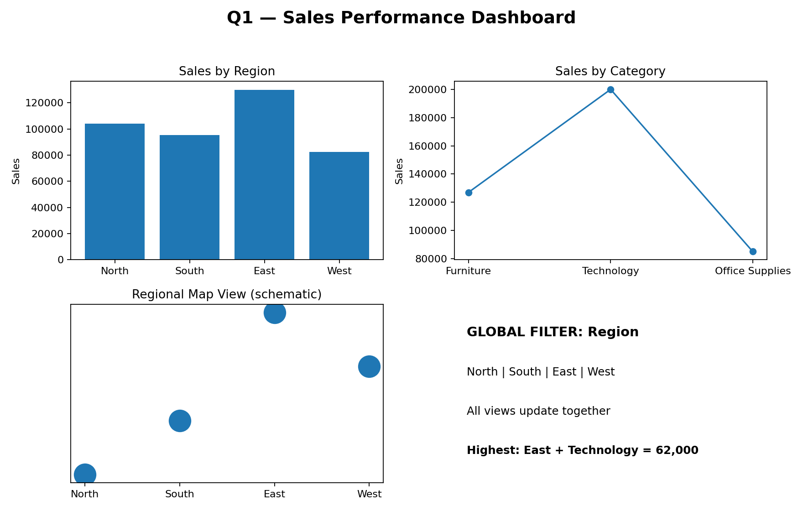
Figure 1: Q1 dashboard-style output from the supplied dataset.
Visual Analysis and Interpretation
East is strongest (130,000). Technology is the strongest category (200,000), and East–Technology is the largest single combination (62,000). The global Region filter supports rapid comparison.
Observation / Design Note
Global filtering makes the dashboard interactive; the map, bar chart and trend view should share a consistent title and readable legend.

Q2. KPI Dashboard with Parameters
Dashboard Requirement
Create KPI cards for Average Rating, Total Employees and Average Attendance, a Department rating bar chart, and a parameter to switch between Rating and Attendance.
Given Data / Verified Values
Average Rating = 7.97 | Total Employees = 10 | Average Attendance = 91.7%. Engineering average rating = 8.75; Support = 7.30.
Tableau Construction Process
Create three KPI sheets → create Department bar chart → create parameter with Average Rating/Average Attendance → create parameter-driven calculated field → place it on bar chart → show parameter control → assemble dashboard.
Dashboard Screenshot / Visualization
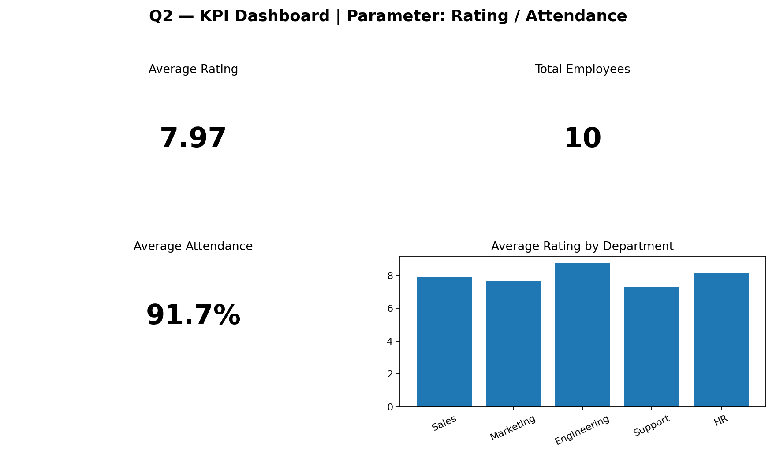
Figure 2: Q2 dashboard-style output from the supplied dataset.
Visual Analysis and Interpretation
Engineering has the highest average rating (8.75) and Support the lowest (7.30). The parameter lets one chart switch measures instead of maintaining separate static charts.
Observation / Design Note
A parameter improves flexibility and reduces dashboard duplication.

Q3. Drill-Down Dashboard with Dashboard Actions
Dashboard Requirement
Create Program summary and Specialization detail views; clicking a Program bar must filter the detail view.
Given Data / Verified Values
Program totals: CSE 195 | ECE 85 | MECH 103 | Overall 383.
Tableau Construction Process
Create Program summary worksheet → create Specialization detail worksheet → place both on dashboard → Dashboard Actions → Add Filter Action → Program sheet as source and Specialization as target → test CSE/ECE/MECH clicks.
Dashboard Screenshot / Visualization
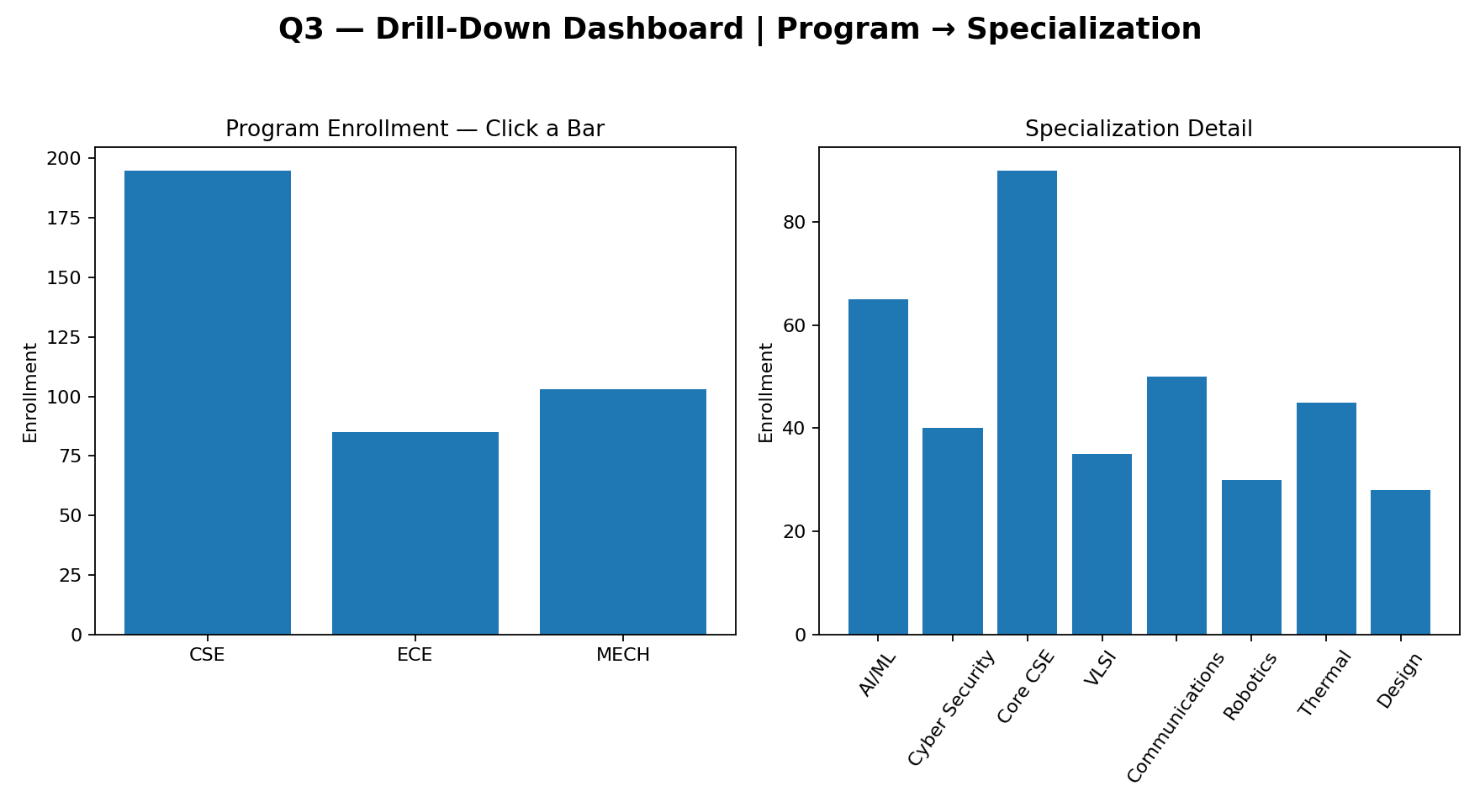
Figure 3: Q3 dashboard-style output from the supplied dataset.
Visual Analysis and Interpretation
CSE has the highest enrollment (195). Selecting CSE can show only AI/ML, Cyber Security and Core CSE in the detail view. This is easier to explore than displaying all specializations at once.
Observation / Design Note
Limitation: users may not discover the click action unless the dashboard includes a clear instruction.

Q4. Multivariate Analysis Dashboard
Dashboard Requirement
Create Advertising vs Sales scatterplot, encode Website Visits by size or color, add trend line, and include a Sales distribution view.
Given Data / Verified Values
Advertising 10–38 | Visits 120–340 | Sales 48–86. Direction is strongly positive.
Tableau Construction Process
Advertising → Columns; Sales → Rows → Scatter → Website Visits → Size/Color → Analytics → Trend Line → create Sales histogram/box plot → combine views → add legend and format.
Dashboard Screenshot / Visualization
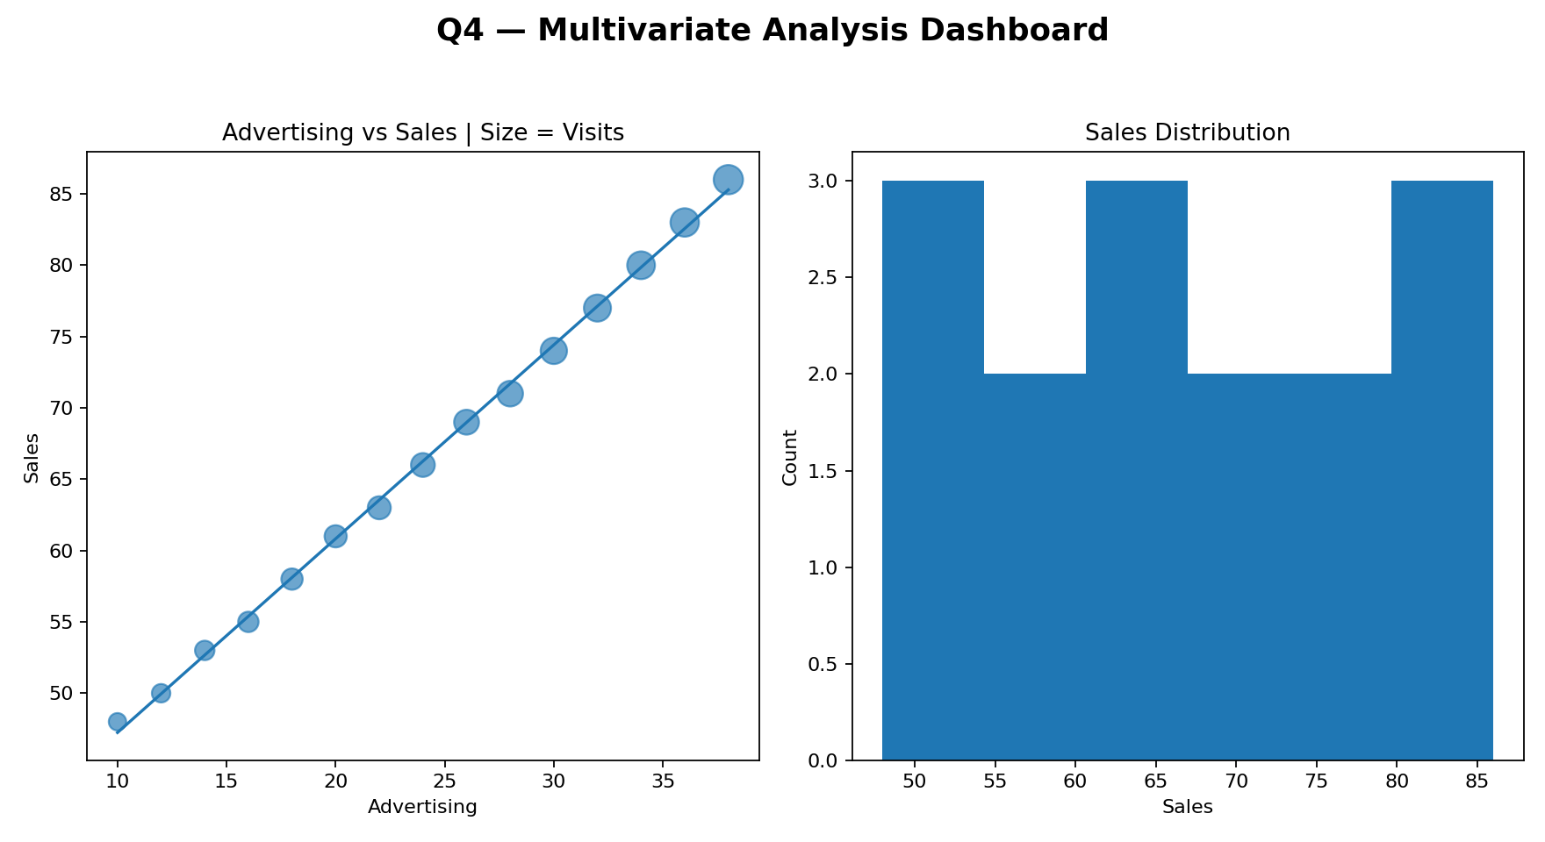
Figure 4: Q4 dashboard-style output from the supplied dataset.
Visual Analysis and Interpretation
Sales increase consistently as advertising increases. Website Visits also rise and therefore provide useful third-variable context, although excessive point size/color can create clutter.
Observation / Design Note
Position remains the strongest encoding for the main relationship; the third variable should remain secondary.

Q5. Misleading Dashboard and Redesign
Dashboard Requirement
Create a misleading dashboard with truncated y-axis, inappropriate emphasis and color; then redesign with proper baseline, ordering, consistent encoding and clear labels.
Given Data / Verified Values
Pass percentages: CSE 91 | ECE 93 | EEE 92 | MECH 89 | CIVIL 90 | AIDS 95 | IT 94. Range = 89%–95%.
Tableau Construction Process
Misleading: create Department/Pass bar chart → narrow y-axis around observed values → inconsistent emphasis. Redesign: zero baseline → sort by Pass Percentage → consistent encoding → data labels → clear title/axis.
Dashboard Screenshot / Visualization
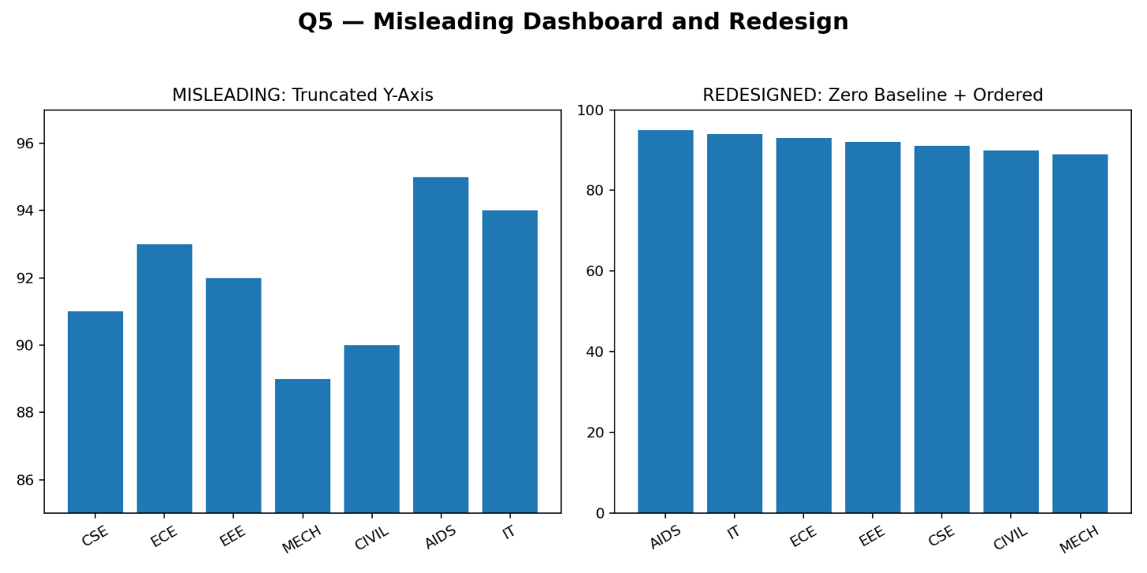
Figure 5: Q5 dashboard-style output from the supplied dataset.
Visual Analysis and Interpretation
The first design exaggerates differences because the y-axis starts near the observed values. The actual range is only six percentage points. The redesigned chart communicates the difference proportionally.
Observation / Design Note
Zero baseline, ordered categories and consistent encoding make the comparison more honest and reduce misleading visual emphasis.

